Assignment 5.3

1. Test whether two vectors are exactly equal (element by element).

vec1 = c(rownames(mtcars[1:15,]))

vec2 = c(rownames(mtcars[11:25,]))

Solution: -

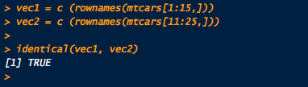

2. Sort the character vector in ascending order and descending order.

vec1 = c(rownames(mtcars[1:15,]))

vec2 = c(rownames(mtcars[11:25,]))

Solution: -

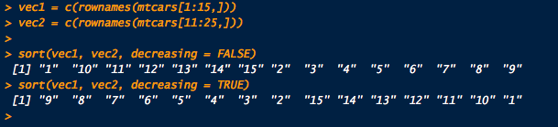

3. What is the major difference between str() and paste() show an example.

Solution: -

Str() provides great information about the structure of some object.

Paste() concatenate vectors after converting to character.

4. Introduce a separator when concatenating the strings.

Solution: -

